**Project 6 Coin Detection – Part 1 – voting for centers**

Name: Ramya Reddy Period: 4 Date: 2/13/22

Did you name your file l061.cpp (Lower case L, then 061)? Yes

Did you create the edge matrix? Yes

Did you create the gradient direction matrix? Yes

Did you create the imagev.ppm (visual of votes)? Yes

Did you use Bresenham's line algorithm for voting? Yes

Did you test on the terminal/jupyterhub? Yes

Below for the easy image provided paste the imagev.ppm, imageCC.ppm you obtained running your code:

What are the 3 values you sed for lower/upper thresholds and also for the threshold for votes:

Lower Threshold: 70, Upper Threshold: 210, Voting Threshold: 70

Instead of applying a single threshold, I made 30x30 patches and found a density for each of the patches. If the density was less than half the default threshold or threshold given through the command line argument, then I’d artificially raise the density to 0.75 of the threshold. Otherwise, I’d raise the density to the threshold. Then, I’d go through each of the pixels in a patch to determine whether if it was a center given if it was greater than the modified density.

imagev.ppm:

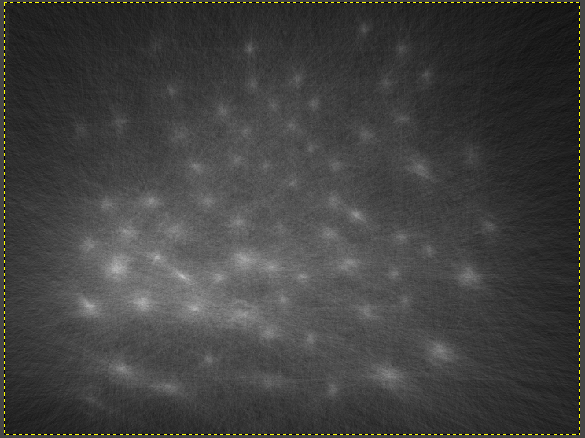

imageCC.ppm:

